|  |  |
| --- | --- |
|  |  |
| Outside Alive Farms |  |
|  |  |
|  | Database for Outside Alive Farms |
|  | Group #1:Thomas Wolf &Max Burzler |

Introductions

|  |  |
| --- | --- |
|  |  |
| Max Burzler | Thomas Wolf |
| A Networking Systems Administrator Student at Horry Georgetown Technical College and manages presentations, and database. | A Programming Student at Horry Georgetown Technical College and manages documentation, and database. |

Milestone 1 Recap

1. **All databases your group discussed with who thought of them**:
   * Database for Outside Alive Farms (Suggested by Max)
   * Database for Local Artisans' Directory (Suggested by Thomas)
   * Database for City-wide Recycling Points (Suggested by Max)
2. **Reasons for choosing or not choosing each one**:
   * Database for Outside Alive Farms: Chosen because Max has direct access to the farm, understands its operations, and believes it would benefit from a structured database system.
   * The reason why he chose this is because he has direct access to the farm, understands its operations, and believes it could benefit from a structured database system.
   * This would be a geo-tagged database of all recycling points within the city, giving detail what materials, each recycling facility point accepts, hours of operations, and user reviews. This could encourage and streamline recycling efforts amongst the residents.
3. **Why choose the one for the project**:
   * We chose the database for Outside Alive Farms due to its practical application. Max has direct ties with the farm, which will facilitate information gathering, and there's a real opportunity to implement and see tangible benefits from our project.
   * While the idea promotes local artisans and is community-focused, it would require extensive research and permissions from each artisan to list their details. This could be time-consuming and might not be feasible within the given timeframe.
   * While the idea promotes sustainability, gathering accurate and up-to-date data for every recycling point in the city might be a challenge. Additionally, maintaining the database would require regular updates which might not be sustainable post-project.

Update Recap

Responsibilities

Max Burzler:

* PowerPoint
* Database:
  + Database initial creation and naming.
  + Data types assigned properly.

Thomas Wolf:

* Word Document
* Database:
  + Entitles and Attributes created.
  + ERD created.
  + Data Dictionary created.

Client Updates:

* As Max has worked at the nursery for several years, he was able to produce a starting database that we can show as a start to the project which consisted of seven tables: Inventory, Person, Plants, Purchase, PurchaseDetail, Sale, and SaleDetail and we have also gone in depth with them about all what is within each column in each table.
* After they’ve reviewed the proposed database, they asked if PotSize, and DeliveryStatus can be added.
* The PotSize would play a role within the database as it categorizes the plants by size because it can be the same plant but a different size an example of this would be a 20-gallon, 65 gallon, and 3-gallon size.
* DeliveryStatus is also used to show if the plant has left the nursery or has been delivered and installed on the customers property.

Latest ERD Table

Latest Data Dictionary

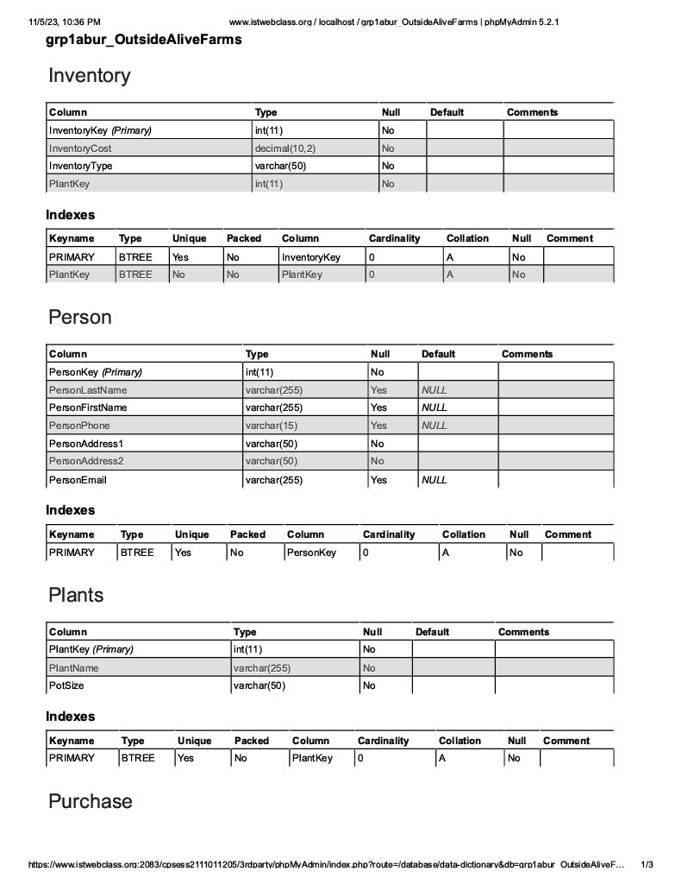

Agenda

To Do by November 19th:

1. Work on the database.
2. Provide insert data into the database itself with sample data.
3. Update the documentation.

# Milestone 2

# Records in the Entities:

1. Inventory:

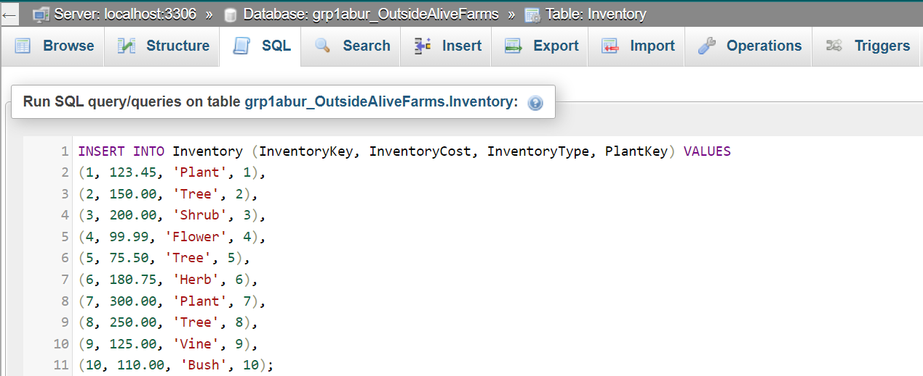

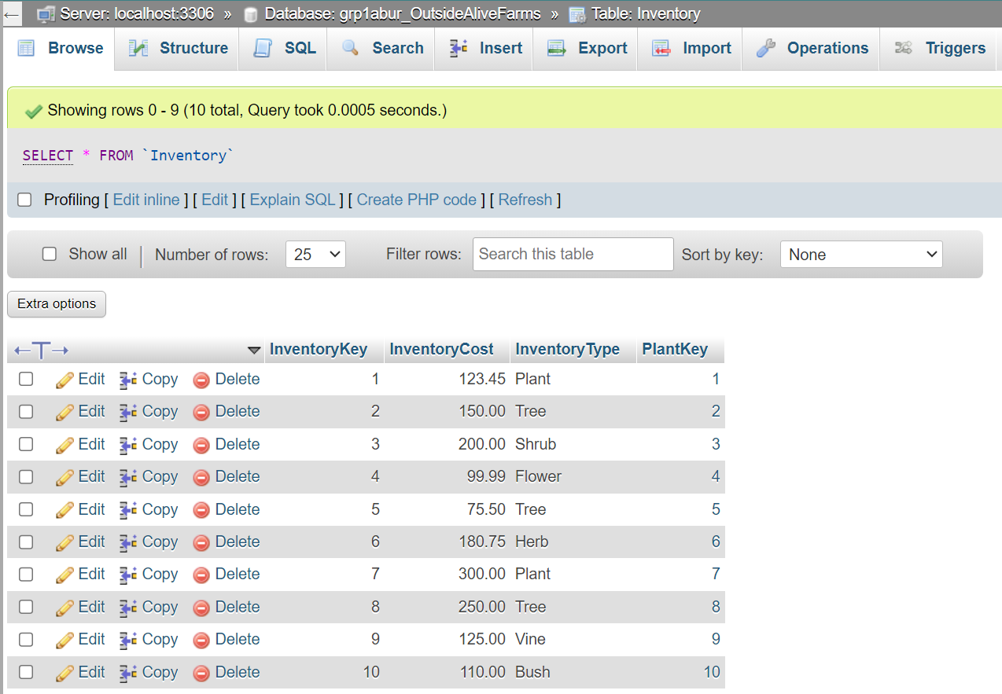

1. Person

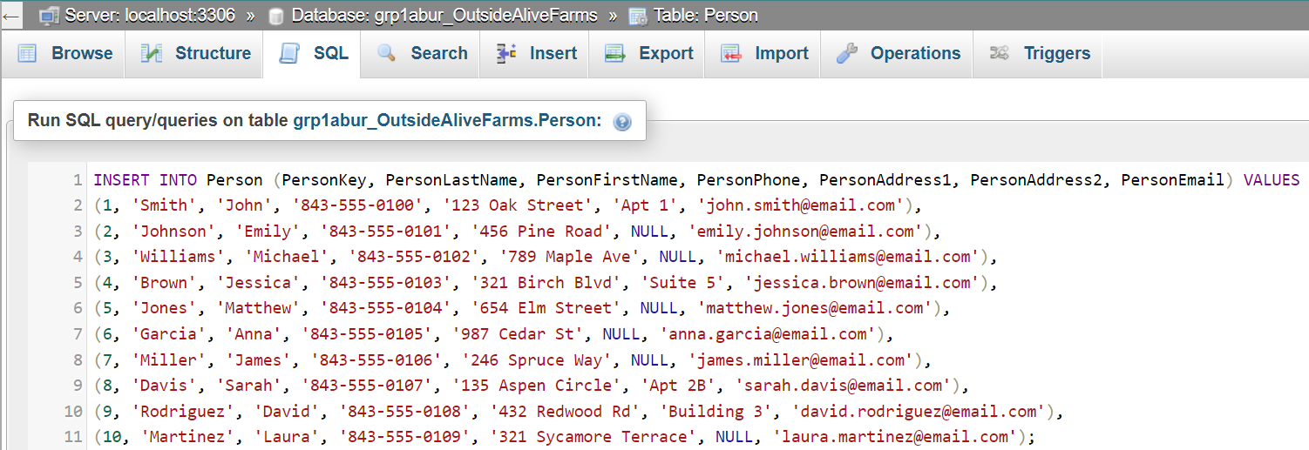

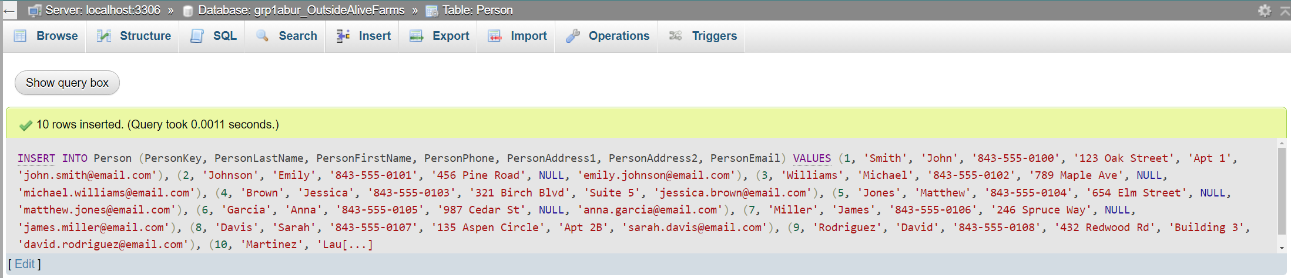

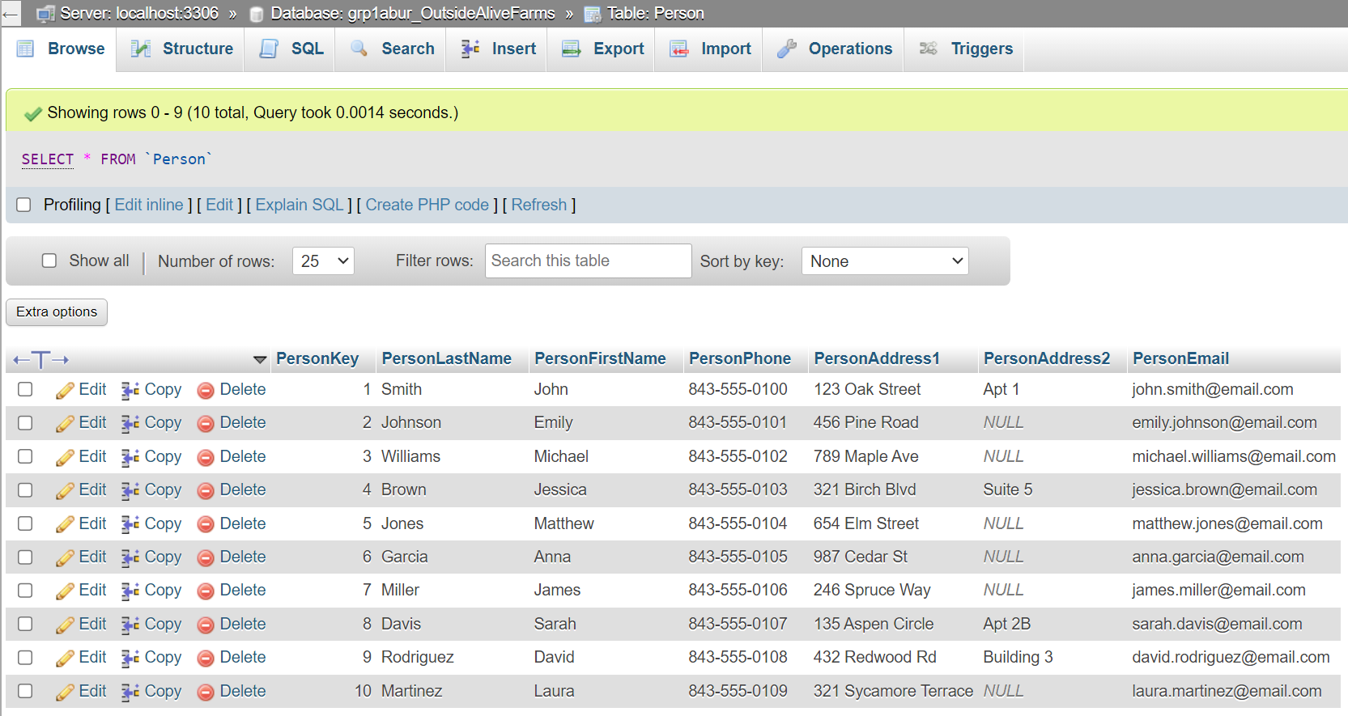

1. Plants

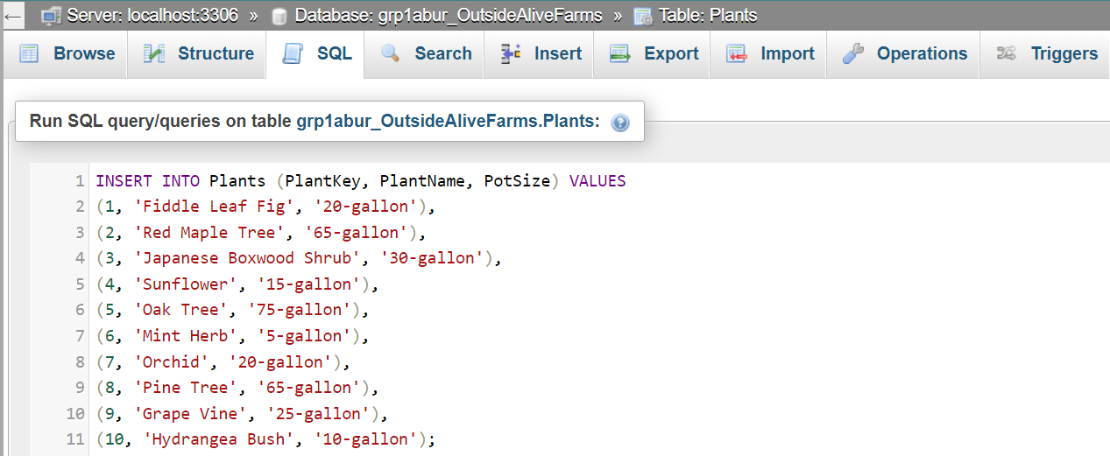

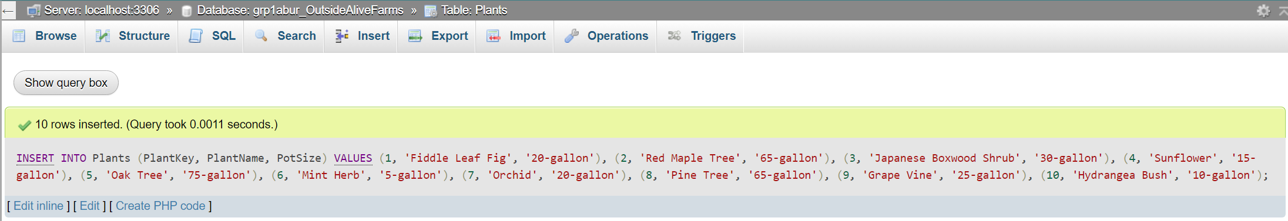

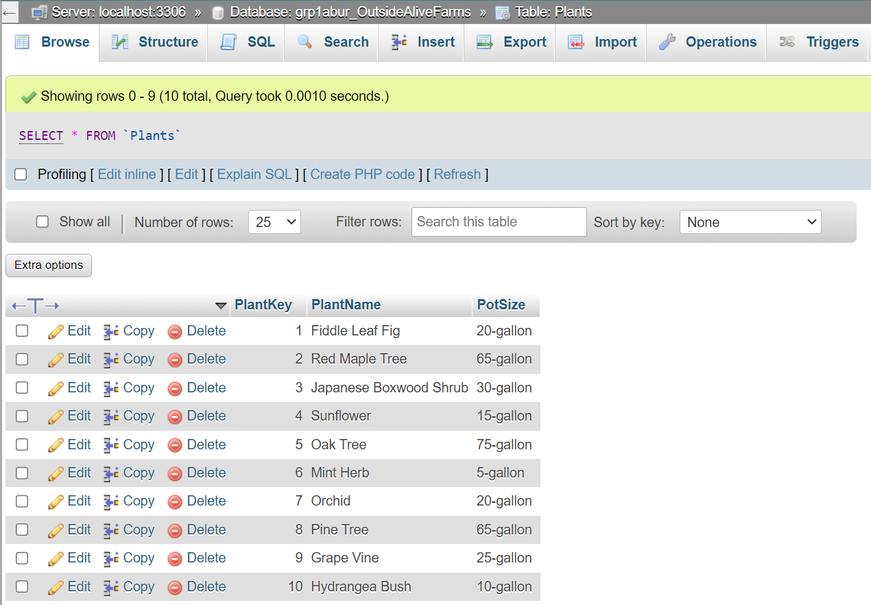

1. Purchase

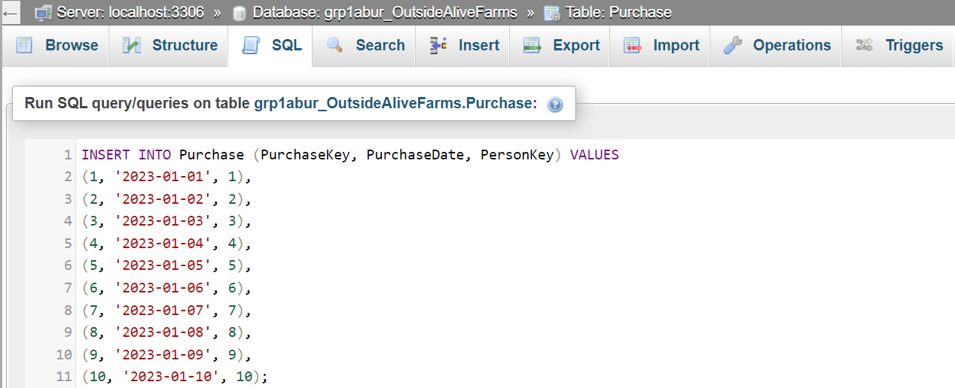

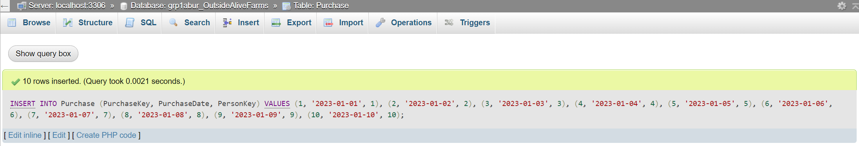

1. PurchaseDetail

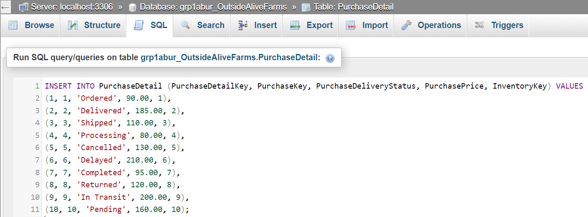

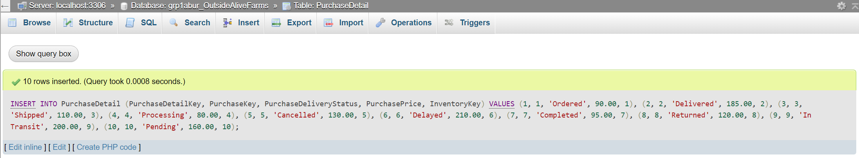

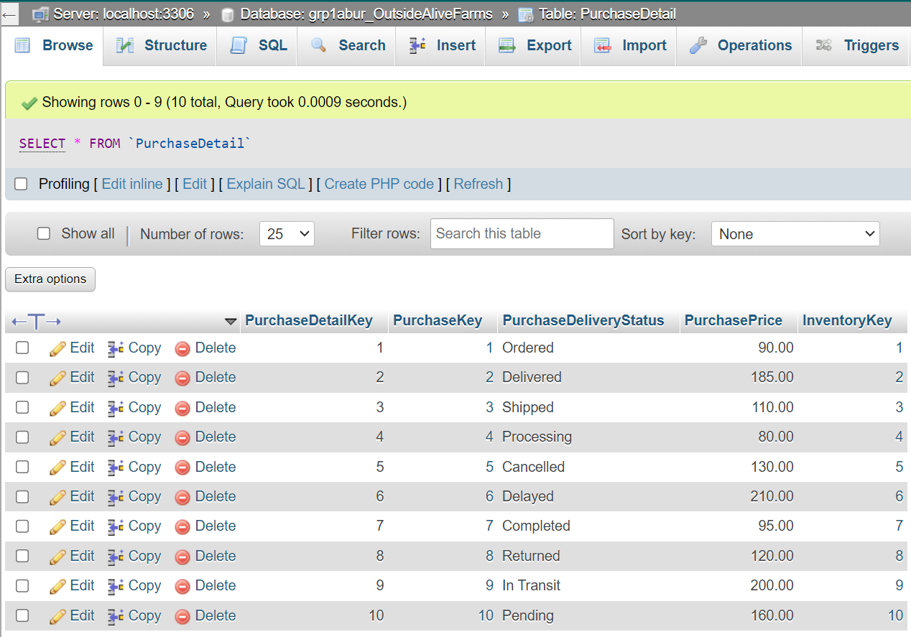

1. Sale

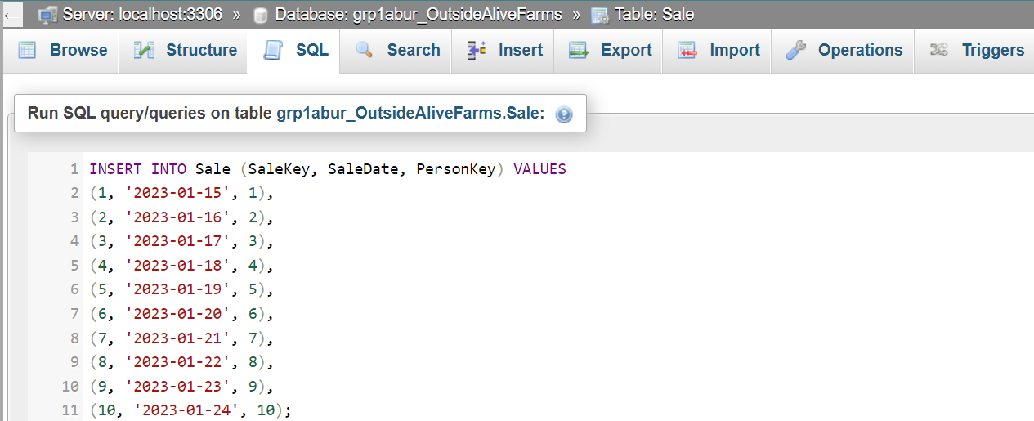

1. SaleDetail

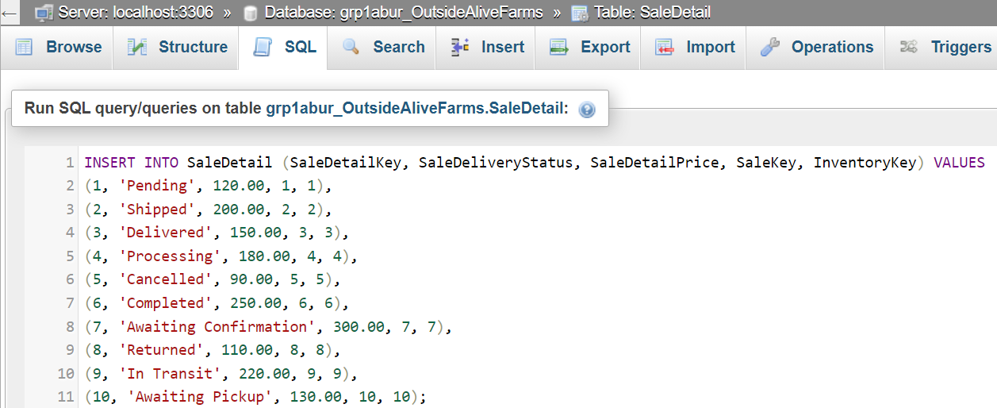

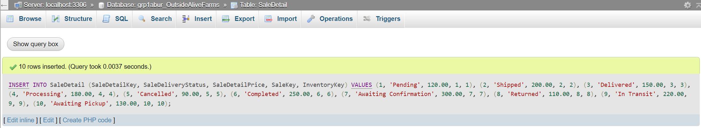

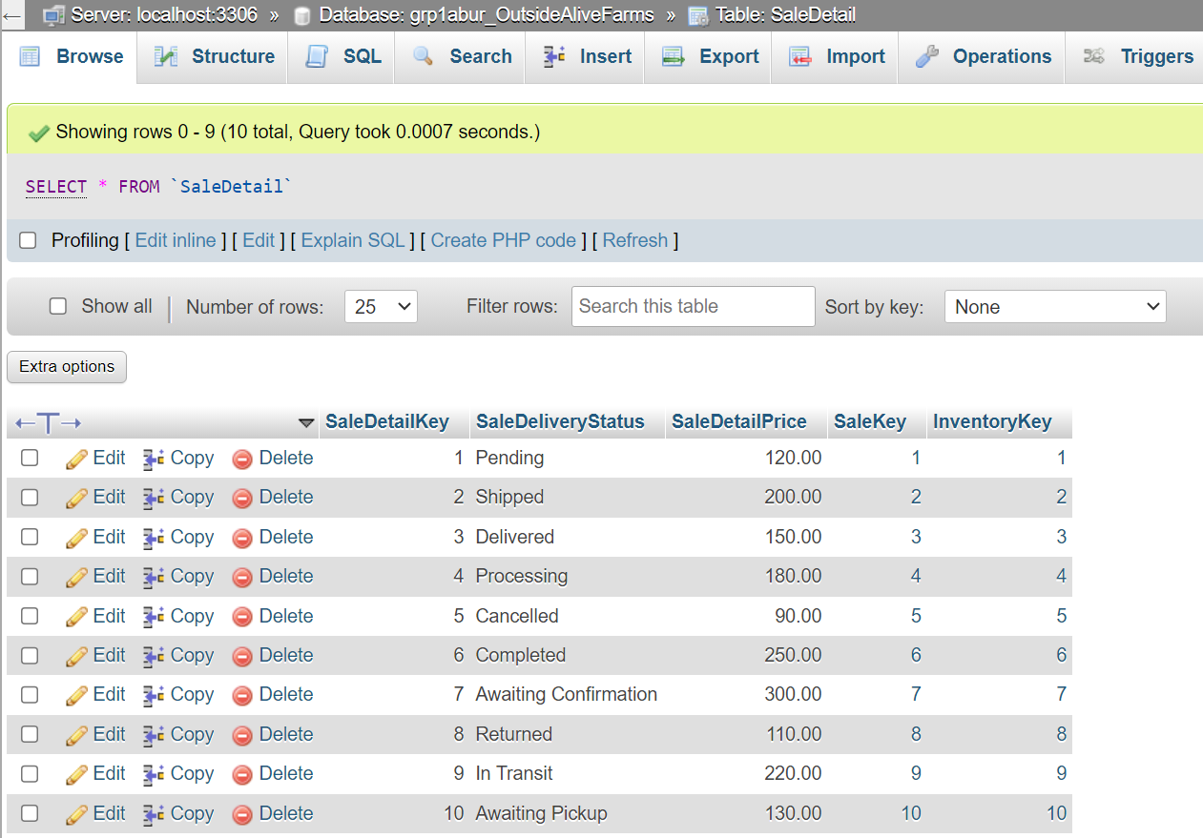

# Update Queries

1. Inventory
   1. Before:



* 1. After:

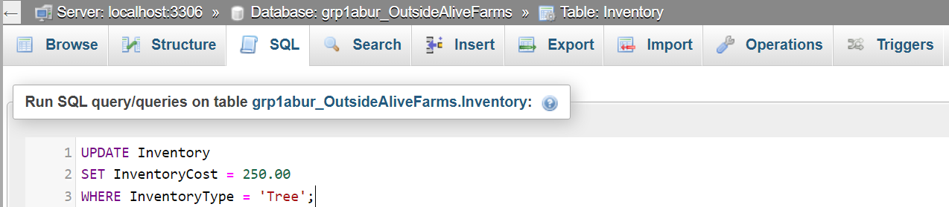

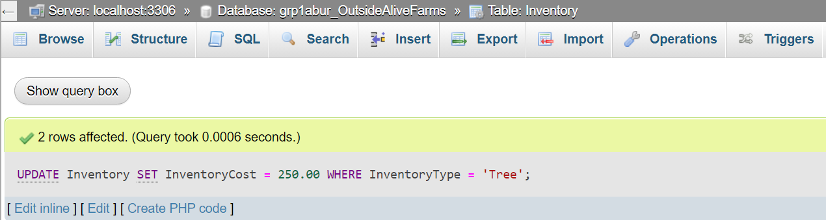

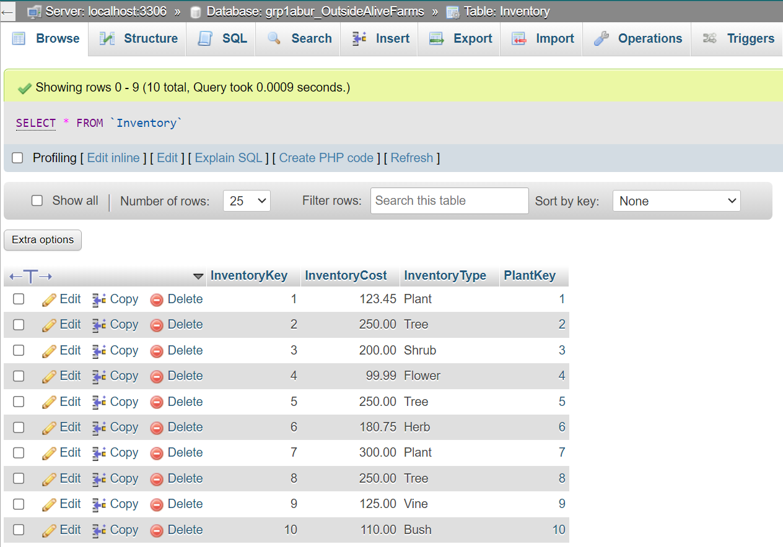

1. Person
   1. Before:



* 1. After:

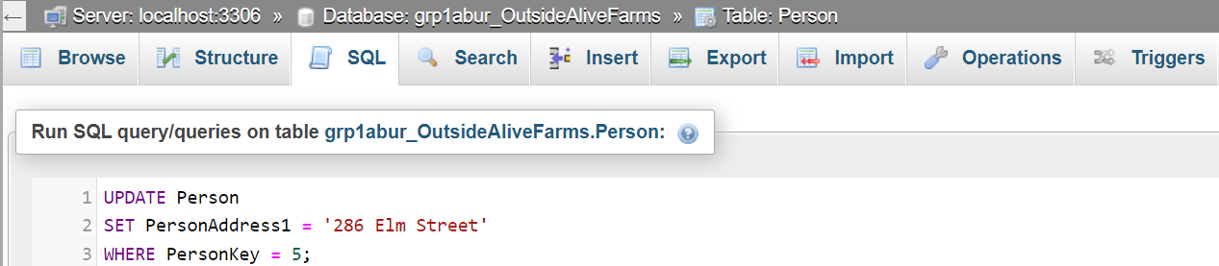

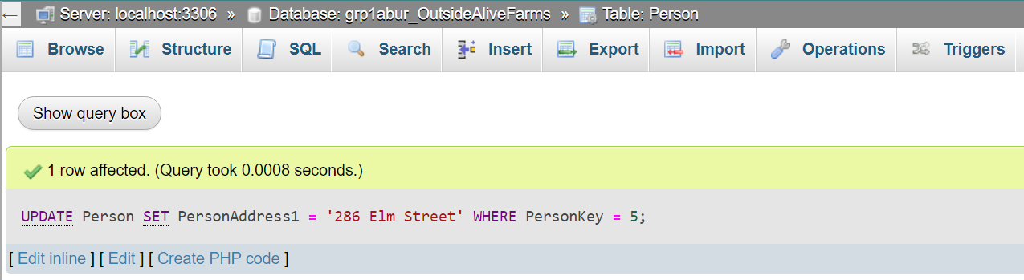

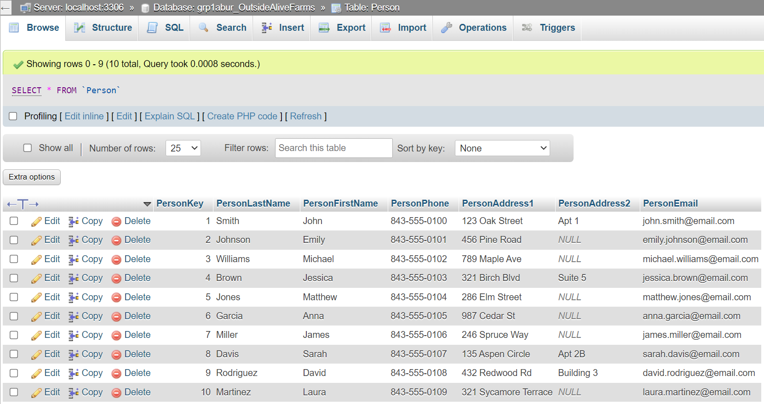

# Inner Join Queries

1. PersonLastName and Sale

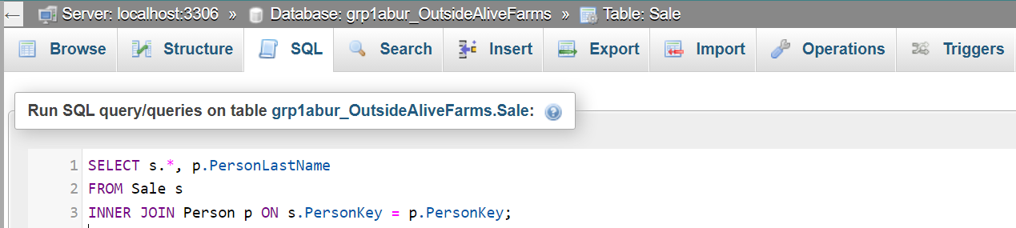

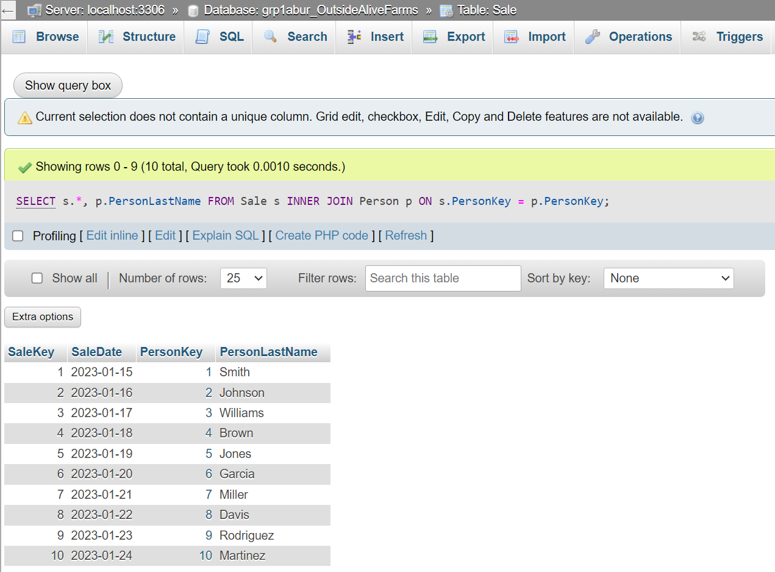

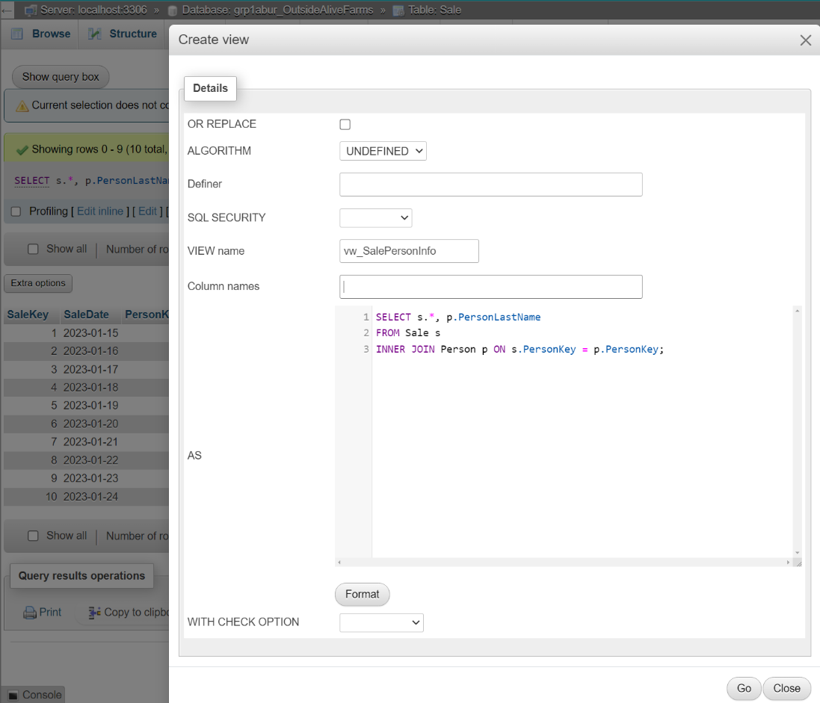

1. InventoryType and PurchaseDetail

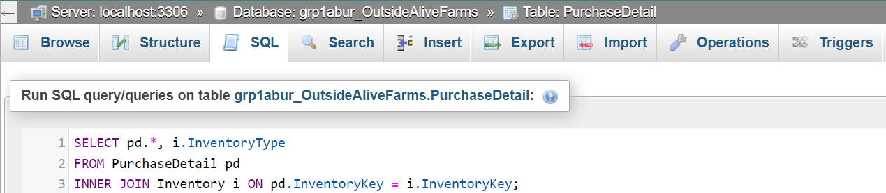

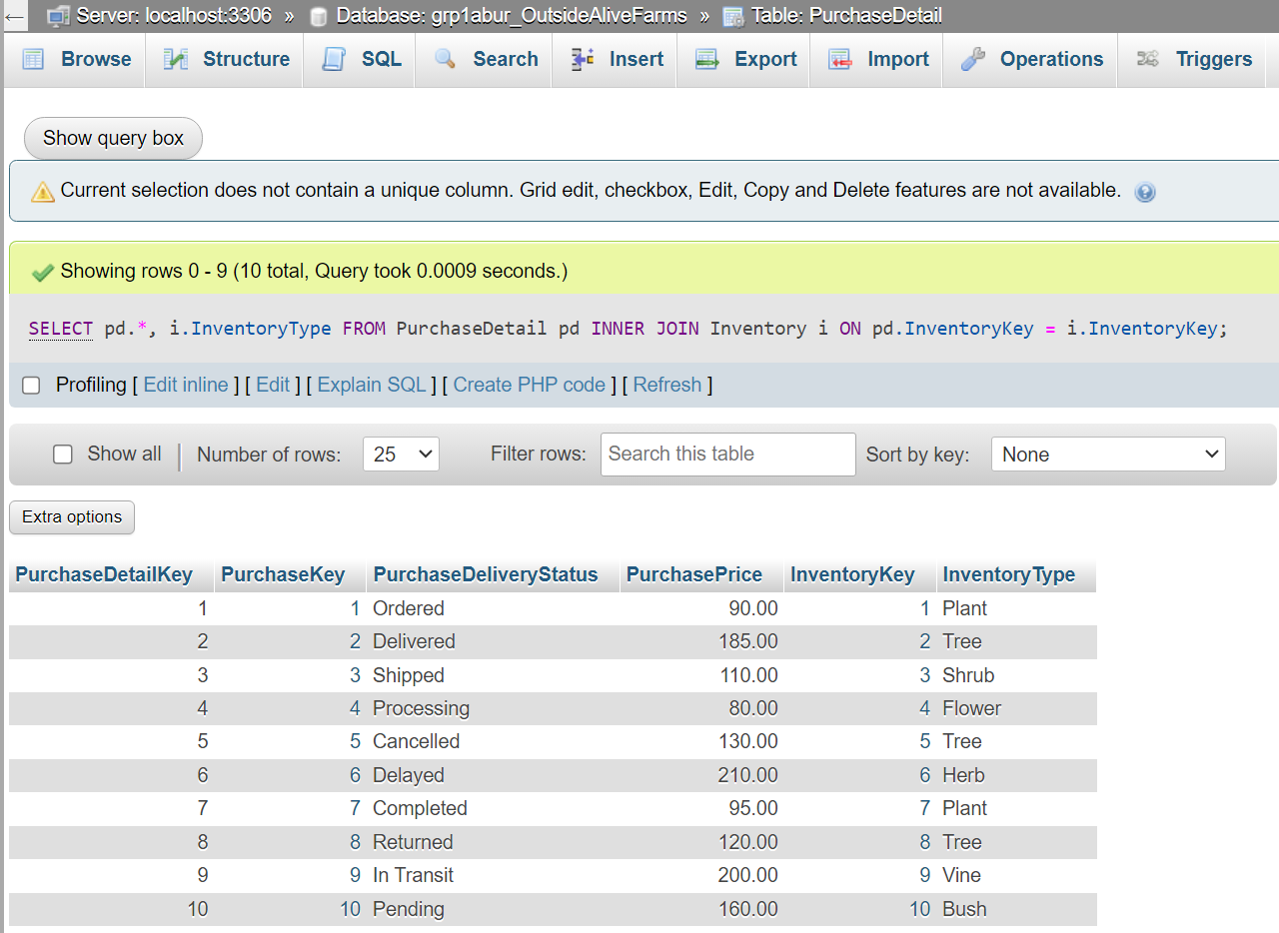

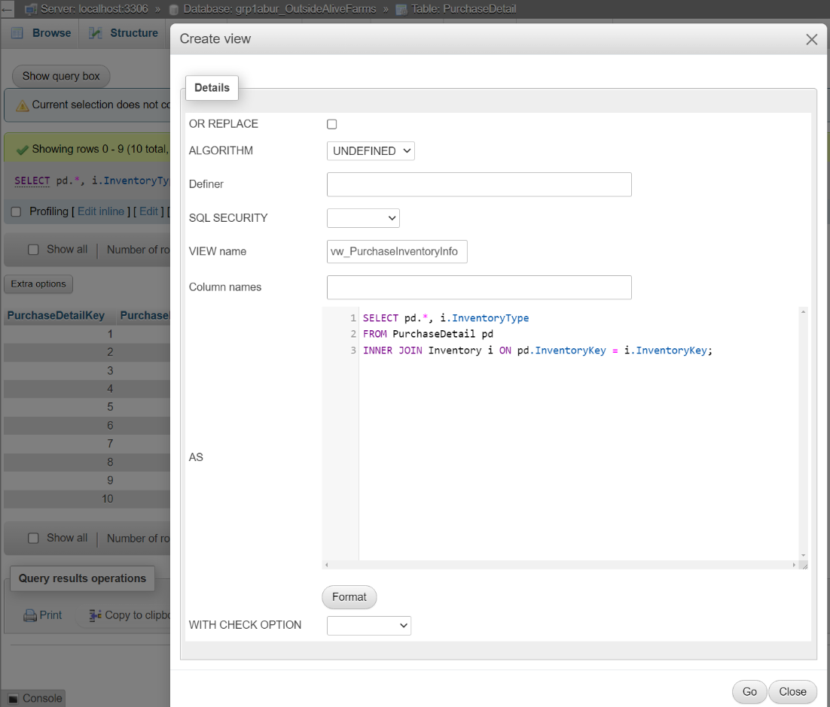

# Disaster Recovery Plan

* We went over with our clients on a potential disaster recovery plan if worst comes to worst:

**Risk Assessment and Planning:**

* Since we are in the southeast located very close to the coastline its essential to keep in mind that Hurricanes, Flash Flooding, and the possibility of Tornados is very likely to occur.
* The possibility of lost data that has been caused by failed equipment/hardware, Compromised data via Hacking, Employees misuse of access and Unauthorized entry.

**Backup Procedures:**

* Have a northern out of state off-site backup, onsite backup, and a master copy.
* Off-Site Backup every 5 days, On-Site Backup every 2 days, once a month of a master copy.
* All backups must be tested multiple times monthly.

**Failover Systems:**

* Have an automatic failover system to switch over to a backup database if the primary fails.

**Data Recovery Strategy:**

* Having an in-depth step by step guide to the for procedures and restoring data for backups.
* Have different procedures scenarios like if it was a partial or complete loss.

**Team Roles and Responsibilities:**

* Assign roles to specific team members like Leader, Technical Support, and Communications.
* Conduct regular training and drills at least once a month.

**Communication Plan:**

* Have communication strategy in place for the teams assigned to database recovery.
* Have methods of communication that is efficient and easy to understand each person's role in the recovery.

**Regular Updates:**

* Periodically review and update disaster recovery plan.
* Have Audits to make sure it complies with industry standards.

**Post-Disaster Evaluation:**

* After a disaster has occurred, we need to analyze what the cause of the incident was and how to prevent this from happening again along with updating the disaster recovery.

Contact Info:

**Max Burzler** [**mburzler@hgtc.edu**](mailto:mburzler@hgtc.edu)

**Thomas Wolf** [**twolf1@hgtc.edu**](mailto:twolf1@hgtc.edu)

All photos: Burzler, Max. Outside Alive Farms.